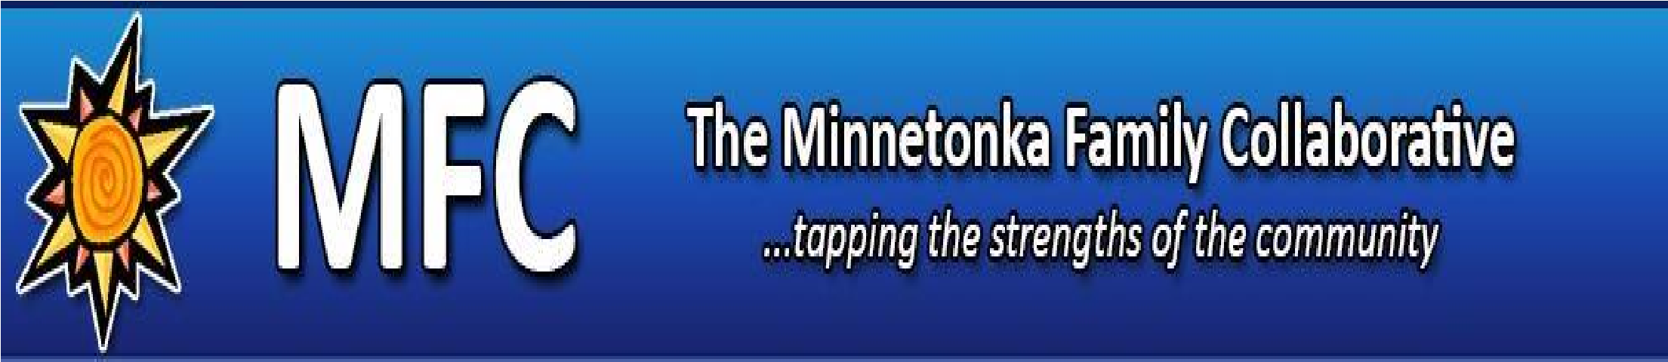
Minnetonka Family Service Collaborative (MFC)
2022- 2023 MFC GRANTS

MFC Overview
The Minnetonka Family Service Collaborative (MFC) is an unincorporated association of designated community partners authorized by federal regulations and state statute overseeing the utilization of federal Medicaid and Title IVE dollars that are reimbursed to states, counties and communities in the form of Local Collaborative Time Study Dollars (LCTS). Community investments the MFC makes each year are based on earnings that come from federal reimbursements for services delivered by Minnetonka School district staff. MFC is governed by a community stakeholder governance group.

MFC Vision: To be the best and most accessible intersection of needs and resources that leads to thriving youth and families in the Minnetonka School District.

MFC Mission: to support and enhance the well-being of children, youth, and families in the Minnetonka School District through partnerships with the community.

2022- 2023 Geographic Focus: Minnetonka School District

2022- 2023 Strategic Priorities: (stated in priority order)
- Children’s mental health (0-21) – help children and youth have full access to resources and credentialed support services with a focus on those families and children with the least access currently.
- Early childhood (0-5) – help provide outreach, screening, service coordination, and other interventions to support the healthy development of children and youth, with a focus on supporting those with the least resources.
- Opportunities for Academic success – help address identified barriers to academic success by supporting system-based responses for school-aged children (e.g. truancy, attendance, nutrition, out-of-school supports, etc.)
- Underage substance use - reduce underage alcohol and drug use by school-aged children.
- Develop and strengthen stakeholder partnerships – act as a strategic community resource supporting the wellbeing of youth and families within the Minnetonka School District boundaries.

Total 2022- 2023 dollars available for fiscal year (July 1 – June 30): $100,000 for community organizations

Timeline:
- February 18, 2022 - Public release of MFC grant program
- Friday, March 18th, 2022– Deadline for completed RFPs (4:00 pm)
- April– Virtual Q&A of applicants with Grant Review Committee – Date TBD
- May 2021– Formal Board Recognition of review panel recommendations
- July 1, 2021 – Funding start date
- Spring 2022 – Final Report Due (approx. – date TBD)

Grantee Eligibility
- Nonprofit or government agency only (grant program is not open to School District programs. Funding for district programs must request inclusion in the “Well-Being” allocation from the District)
- Good standing/no adverse action from the MN Charity Review Council (if applicable)
- Timely and accurate completion of RFP form

Criteria for funding
A well-articulated proposal that:
- Clearly aligns closely with MFC vision/mission
- Makes the case for meeting at least one of the MFC strategic priorities
- Fits clearly within MFC geographic focus
- Directly serves individuals and families within the Minnetonka Public Schools population and/or who are scheduled to enter the Minnetonka Public Schools
- Has clear, concise, logical, achievable objectives and support the case for support
- Includes a project budget and budget narrative that are clear and complete
- Demonstrates a method for measuring results that impact the strategic priority areas
In addition, preferences will be given to:
- Programs that demonstrate a direct impact on a large number of children and families within the District
- Evidence-based/promising practices as part of program delivery
- Projects that contribute to community-wide systems change (more collaborative partners, improved access, improved coordination of services, improved resource allocation, improved efficiency and effectiveness, reduced costs, etc.)
- Projects which bring together different sectors and systems to collaborate for results (government, non-profit and/or business - children’s mental health, child welfare, juvenile corrections, child-care, home visiting, primary care/clinical care, etc.)

Additional Expectations:
- Grantees are expected to be an active/attending member of the MFC.
- Grantees are expected to share/report program results and strategies to the MFC community.

What MFC does not fund:
- Activities that have a specific religious or political purpose
- Attendance at or travel to conferences or costs related to conferences
- Endowments
- Scientific research
- Professional development expenses for staff
- Purchase of electronic equipment to support the initiative

Reporting Requirements
- MFC fiscal year ends June 30th
- MFC final report (format to be sent to you electronically) due at a date TBD in the spring of 2023 that includes a summary of outcomes (going beyond outputs) that were achieved that made a difference in the lives of your clients served
- Submission of a financial report documenting that the grant was used for the purpose intended and a copy of the final program budget with actuals

Any questions, please contact Cari Lindberg at: Carine.Lindberg@Minnetonkaschools.org

